November 9, 2022

**CloudFit Software Named to Inc. Magazine’s Vet100 List**

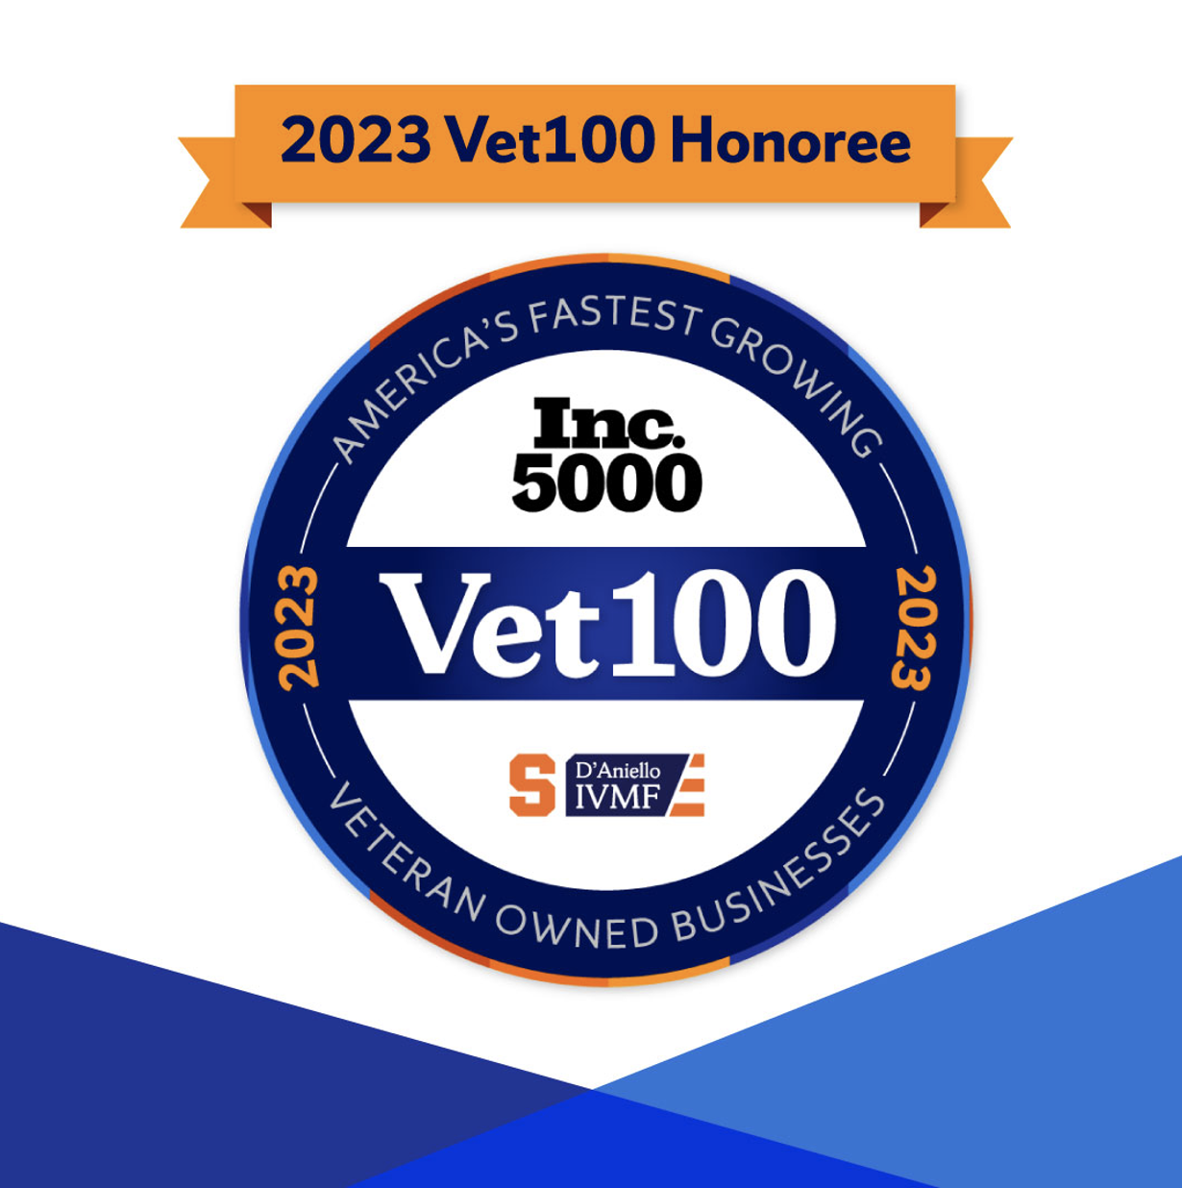

*Lynchburg-area company ranked among 100 Fastest-Growing Veteran-Owned Businesses*

Lynchburg, VA (November 9, 2022) – CloudFit Software has been named to the annual [Vet100 list](https://ivmf.syracuse.edu/programs/entrepreneurship/growth/veteran-edge/vet100/)—a compilation of the nation’s fastest-growing veteran-owned businesses. The ranking, created in partnership with Inc. magazine and Syracuse University’s D’Aniello Institute for Veterans and Military Families (IVMF), was born out of the iconic [Inc. 5000](https://www.inc.com/inc5000/index.html) list of the fastest-growing private companies based in the U.S. Both distinctions are considered hallmarks of entrepreneurial success.

Originally established as the Vet50 list, the list was expanded in 2020 to include 100 veteran-owned businesses in acknowledgment of the growing culture and success of veteran entrepreneurs.

“We’ve been blessed to grow a great company based on our unique experience and capabilities, along with our culture of servant leadership.  We employ many veterans as well as non-vets, but all have a common bond of a desire to serve others and to be accountable to our customers.  Being able to mobilize the CloudFit culture and our great people in service to our customers, both in government and across other regulated industries, is our growth multiplier.  On behalf of our CloudFit family, I’m humbled and truly honored for this recognition.” said CloudFit Software CEO Joe Martin.

“Economic prosperity is so important to so many aspects of American life, from home and main street to even our standing in the world,” says Scott Omelianuk, Inc.’s Editor in Chief. “Given that prosperity is driven by small business, and given, we now know, the impact Veteran founders have on that small business, we can only continue to recognize them and say, again, thank you for your service.”

“In almost every industry we see veteran-owned businesses excelling by applying leadership and management skills they learned from their military service and having tremendous impact in their communities,” said Dr. Mike Haynie, Syracuse University Vice Chancellor as well as the Founder and Executive Director of the IVMF. “Veteran entrepreneurs are a critical component of the small business landscape, and we’re excited to see some of our program graduates recognized by Inc., particularly those who are enjoying recurring placement on the Vet100 list. We appreciate Inc.’s commitment to highlighting these success stories. One specific area we’re proud to see growth this year is the number of those businesses whose veteran business owners are women. All of us here at the IVMF take pride in moments like these and we’re grateful for the continued partnership with Inc.”

Vet100 honorees will be formally recognized during the Vet100 Dinner and Awards Ceremony at IVMF’s Veteran EDGE Conference in Dallas, TX.

For more information on the Inc. Vet100 list, visit: <https://ivmf.syracuse.edu/vet100/>

**About CloudFit Software**  
CloudFit Software, Inc was founded in March of 2018 and merged with Composable Systems, LLC in August of 2018 to form CloudFit Software, LLC. CloudFit is now leading the market in “Managed Scenarios” for cloud across Fortune 500, DoD and Regulated Industries. While CloudFit primarily exists to implement, manage and secure critical services and applications to the cloud, it has a great mission with its charities:*KidFit* — uses athletics as a conduit to provide mentorship and opportunities for all kids regardless of their ability to play and*JobFit* — lowers barriers for high school and college students to achieve great IT careers.

**About Inc. and the Inc. 5000**

The world’s most trusted business-media brand, Inc. offers entrepreneurs the knowledge, tools, connections, and community to build great companies. Its award-winning multiplatform content reaches more than 50 million people each month across a variety of channels including websites, newsletters, social media, podcasts, and print. Its prestigious Inc. 5000 list, produced every year since 1982, analyzes company data to recognize the fastest-growing privately held businesses in the United States. The global recognition that comes with inclusion in the 5000 gives the founders of the best businesses an opportunity to engage with an exclusive community of their peers, and the credibility that helps them drive sales and recruit talent. The associated Inc. 5000 Conference is part of a highly acclaimed portfolio of bespoke events produced by Inc. For more information, visit [www.inc.com](http://www.inc.com/).

**About Syracuse University’s D’Aniello Institute for Veterans and Military Families**

Syracuse University’s D’Aniello Institute for Veterans and Military Families (IVMF) delivers no-cost career training and entrepreneurship programs across the US and globally. And we help ease the transition after service back into communities for service members, veterans and their families as well as prepare them for successful careers and business ownership. We’ve supported over 170,000 to date. It’s our mission to support theirs. For more information, visit ivmf.syracuse.edu and follow the IVMF on Facebook, Twitter and Instagram.

Filed Under: [Uncategorized](https://www.cloudfitsoftware.com/category/uncategorized/)